|  |  |
| --- | --- |
| **Name** | **M.Faizan Azam, Muhammad Asad** |
| **Reg no** | **2019-EE-381,2019-EE-383** |
| **Marks** |  |

**Open Ended lab**

**Lab Title:**

**Common Drain Mosfet Amplifier**

As discussed under the section on JFETs, the common drain amplifier is also known as the source follower. The prototype amplifier circuit with device model is shown in Figure 13.3.113.3.1. As with all voltage followers, we expect a non-inverting voltage gain close to unity with a high ZinZin and a low ZoutZout.

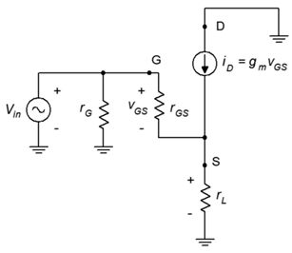

Figure 13.3.113.3.1: Common drain (source follower) prototype.

As is usual, the input signal is applied to the gate terminal and the output is taken from the source. Because the output is at the source, biasing schemes that have the source terminal grounded, such as zero bias and voltage divider bias, cannot be used.

**Voltage Gain**

The voltage gain equation for the common drain follower is developed as follows: We begin with the fundamental definition that voltage gain is the ratio of voutvout to vinvin, and proceed by expressing these voltages in terms of their Ohm's law equivalents. The load is now located at the MOSFET's source, and thus can be referred to as either rLrL or rSrS.

Av=vout/vin=vS/vG=vL/vG

Av=iDrL/iDrL+vGS

Av=gmvGSrL/gmvGSrL+vGS

Av=gmrLgmrL+1

Av=gmrSgmrS+1

**Input Impedance**

The analysis for source follower's input impedance is virtually identical to that for the common source amplifier. The same commentary applies regarding the simplification of gate biasing resistors to arrive at the value of rGrG.

Zin=rG||rGS≈rG

**Output Impedance**

In order to determine the output impedance, we modify the circuit of Figure 13.3.113.3.1 by separating the load resistance from the source bias resistor. This is shown in Figure 13.3.213.3.2.

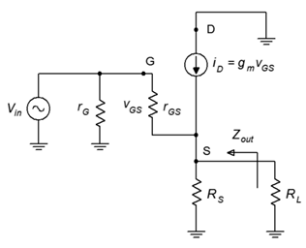

Figure 13.3.213.3.2: Source follower output impedance analysis.

Looking back into the source from the perspective of the load we find that the source biasing resistor, RSRS, is in parallel with the impedance looking back into the source terminal.

Zout=RS||Zsource

Zout=RS||Zsource

To find ZsourceZsource, note that the voltage at the source is vGSvGS and the current entering this node is iDiD. The ratio of the two will yield the impedance looking back into the source.

Zsource=vGS/iD

Zsource=vGS/gmvGS

Zsource=1/gm

Therefore, the output impedance is

Zout=RS||1gm

Zout=RS||1gm

It is obvious that the higher the transconductance, the lower the output impedance. As noted earlier, a large transconductance also means that the voltage gain will be close to unity. As a general rule then, a large transconductance is desired for the source follower.

**Circuit Diagram:**

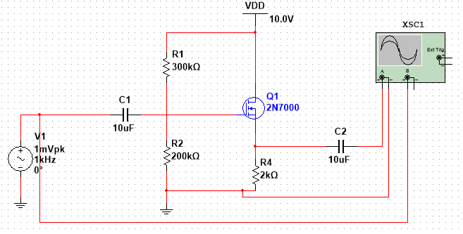

**Output Waveform :**

